What crimes are most likely to remain unresolved? (Yevgeniy)

First, I’ve gathered data from a Police API “street-level-crime” for the period of 2020-01 until 2020-12. This have provided me with detailed data on types of crime, their location, and most importantly the outcomes of it.

Then, I’ve funnelled all data into a DataFrame where in total 322759 crimes have happened during that period. After cleaning the crimes with no recorded outcomes only 268414 were left.

Afterwards, outcomes per crime category were grouped and counted with the following data discovery being plotted on a bar chart. In total 14 bar charts were created, 1 for each crime-category in the hopes of witnessing a differing trend among the crimes. Upon my surprise, no differences between crime type were found. All of crime were just as likely to remain unsolved ~95% of cases remain unsolved. I have created 14 bar charts showcasing the Outcomes vs Outcomes Count per Crime Category. It is important to note that the trend of most popular outcomes and overwhelming majority of them remaining unsolved is apparent in all of them. Lets take a look at most frequent crime type: Violent Crime (Figure 1.). The trend observed here is the same as in other crime types with minor differences in value. 2 of most prominent bars are: “Unable to prosecute suspect” and “Investigation complete; no suspect identified” respectively. This accounts for 79.5% of all cases. With the other 17% of cases being unavailable to access. Remainder of cases are spread over cases being either solved with a warning or being currently in court or police have refused to work on that case as it is not “in the public interest”. Interestingly Police have a statement surrounding such astonishingly low rate of cases solved (Figure 2.)

In summary, answering the question of “What crimes are most likely to remain unresolved”, the answer would be: “All of them” every crime type has around ~80 case of unsolved crimes mostly due to insufficient evidence or inability to catch the culprit with the remainder ~14-17% being unavailable to access. It is worth noting that around ~ 50,000 cases were not taken into consideration due to lacking any data on their outcomes.

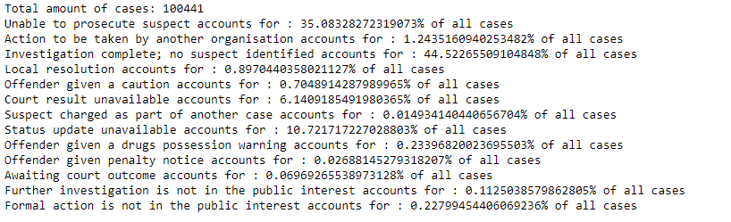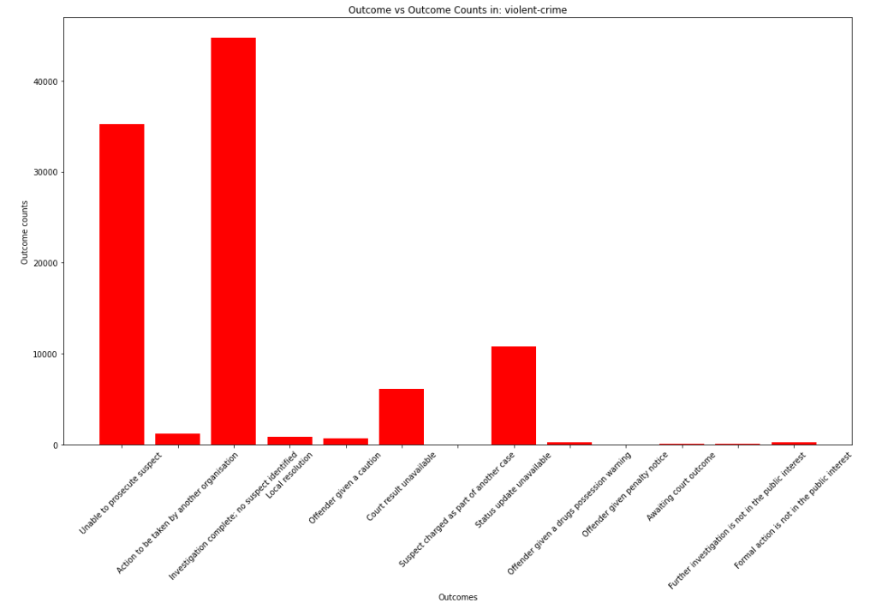

*Figure 1. Bar Chart for Violent Crime. Outcomes vs Outcome Counts.*

*Figure 2. Police Statement over low rate of action taken for cases.*